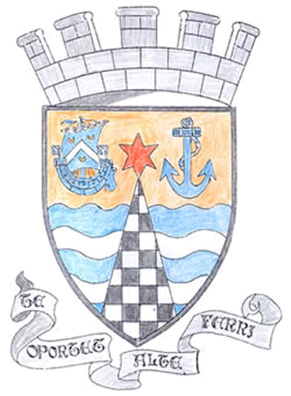
Tayport Ferryport –On-Craig

Community Council

MINUTES OF THE MEETING OF
THE TAYPORT FERRYPORT ON CRAIG COMMUNITY COUNCIL
HELD IN THE BURGH CHAMBERS ON MONDAY 3rd JUNE 2019 AT 19:00 HRS

Present: Chair: Mr D Gray: Secretary: Mr G M Beat :Vice Chair: Mr M Mitcham
Mrs M Taylor, Mrs S Walker ,Mrs L White , Ms N Walker Mrs H Lowe

In Attendance: Cllr Bill Connor , Cllr Tim Brett

Apologies: Mr J Kinnear , Mr D Myles

Declarations Of Interest: Mrs H Lowe , Mr D Gray

Resignation: Jamie Mcleod has stood down from representing Madras College on the Community Council
as he no longer attends Madras College , he remains a member of the Scottish Youth
Parliament , we wish him well and every future success

The Minutes of the AGM held on 6th May were agreed
.
Matters arising from the previous minutes :

1. Acknowledge there is still no Audit Report from Tayview Surgery
2. Tayport FC are still negotiating on the sale/lease of the football ground
3. Charginig point for Electric cars at Tayport Harbour .

Agenda Items/Discussion | Action
Police Matters:
.
Apologies given for non Attendance , Written Report appended

Fife Council and Other Correspondence:

1. Fife Events Quick Reference Guide , passed to interested parties .
2. Tayport Seawall repairs , to be completed this Summer
3. Tayport Heritage Report – showing signage of routes through Tayport
4. Review of Fife Council Community Council Scheme – Discussed
5. Launch of expanded multi operator bus ticket scheme covering Dundee and]
East Fife from June 3rd
6. Gala – Community Council Stall – Discussed
7. Christmas Lights – our new contact for Blachere is the Project Manager ,
Donna Read
8. Beautiful Fife Judging on 18th July , contact Community Garden and all others
concerned
9. Local Community Projects – some money available
10 Tayport Surgery Report – Discussed

Planning Applications:

1. 18/02124/NMV1 Erection of dwelling houses (substitution of housetype) on
Land to the north and south of Forgan Drive , Drumoig No Objections
2. 19/01317/FULL Change to window materials/rooflights , 42 Craigie Hill ,
Drumoig No Objections
3. 19/01287/LBC Consent for alterations a No1 Whitenhill DD6 9BZ
No Objections

Fife Councillors Report:

Written reports appended

Questions for Fife Council:

Questions to be answered at next meeting

A.O.C.B

Citizen of the Year and Group Awards
Agreed to provide £100.00 to Gala

Next meeting to be held in the Burgh Chambers at 7.00pm on 1st July

Meeting ended at 9.00 pm

